**PRACTICAL 5**

Aggregation with MONGODB

Comparison Operators

1. Find cities where the population is exactly 15338

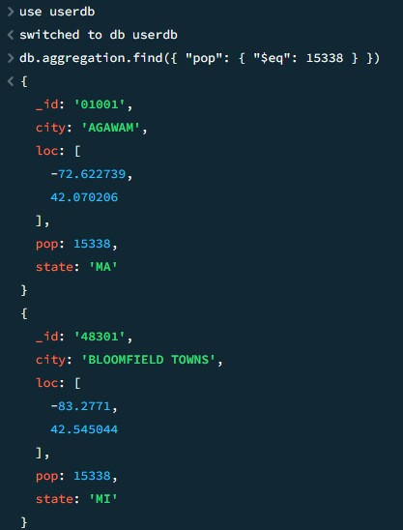

1. Find cities where the population is not 15338.

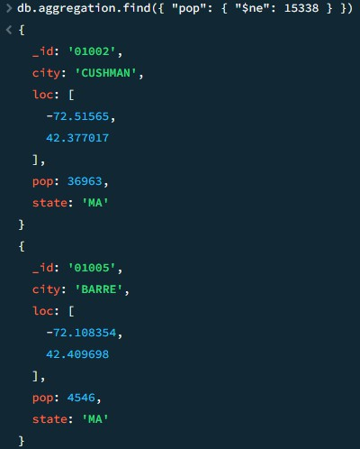

1. Find cities where the population is greater than 20,000.

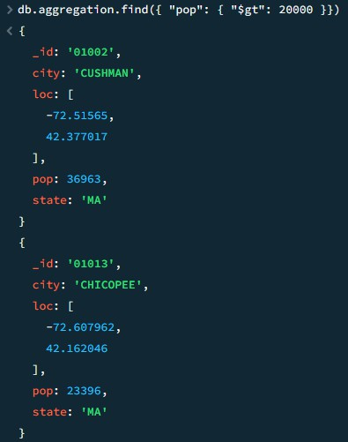

4.Find cities where the population is at least 20,000.

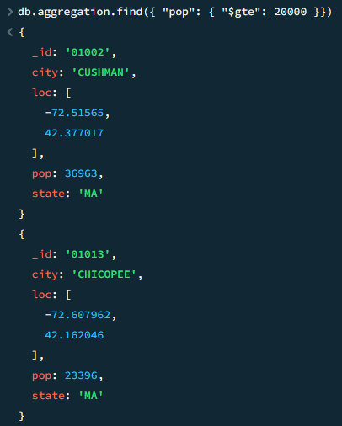

1. Find cities where the population is at least 20,000.



1. Find cities where the population is less than 2,000.

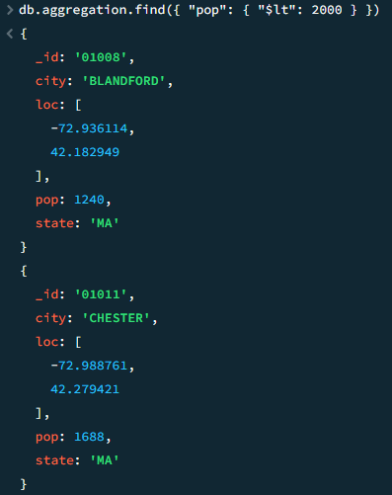

1. Find cities where the population is at most 2,000.

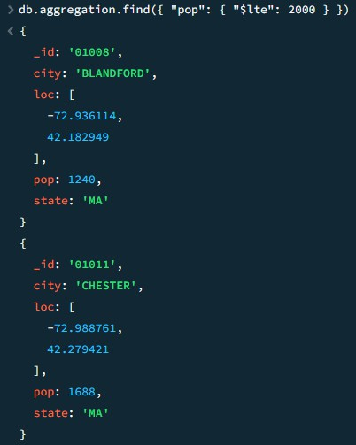

1. Find cities where the population is either **15,338, 36,963, or 4,546**.

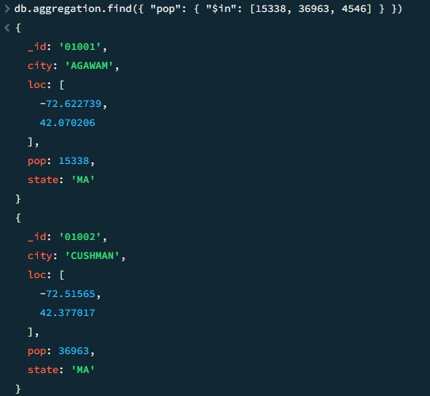

1. Find cities where the population is **not 15,338, 36,963, or 4,546**

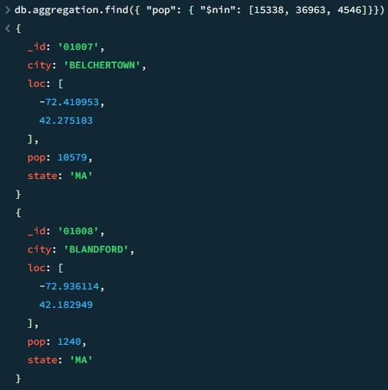

Logical Operators

1. Find cities where the population is greater than 20,000 **AND** the state is "MA".

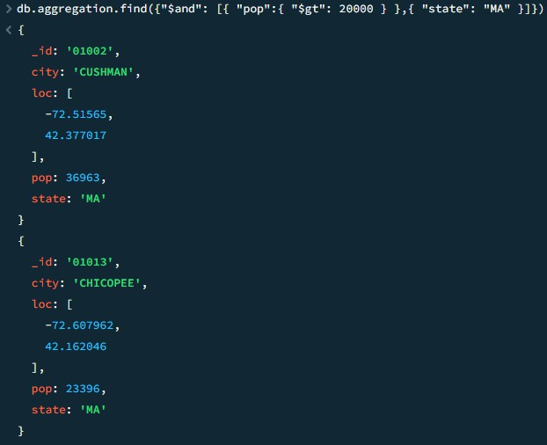

1. Find cities where the population is either **less than 2,000 OR** greater than **40,000**.

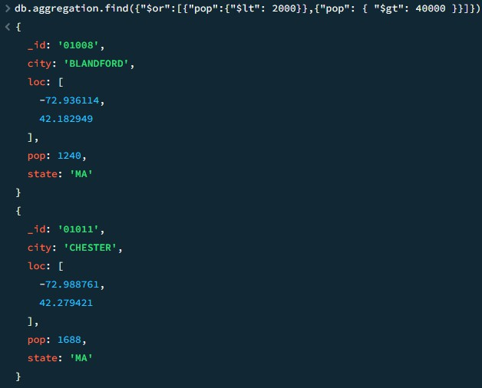

1. Find cities where city is not equal to “Barre”.

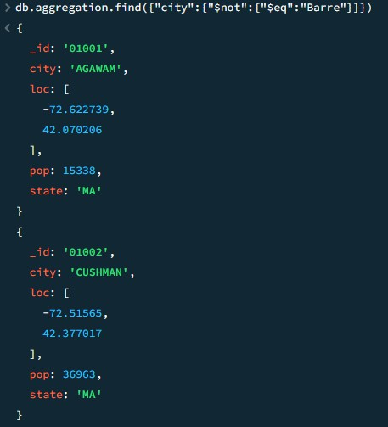

1. Find cities that are **NOT** "SPRINGFIELD" **AND NOT** "WORCESTER".

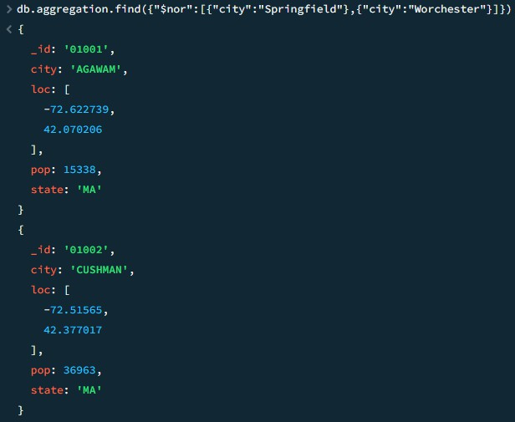

Element Operator 1.exists

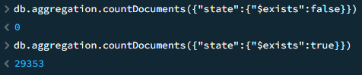

2.type

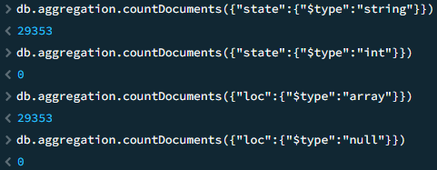

Array Operators. 1.all

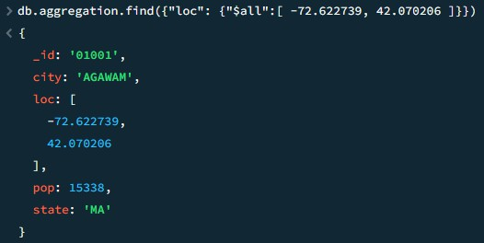

2. elemmatch

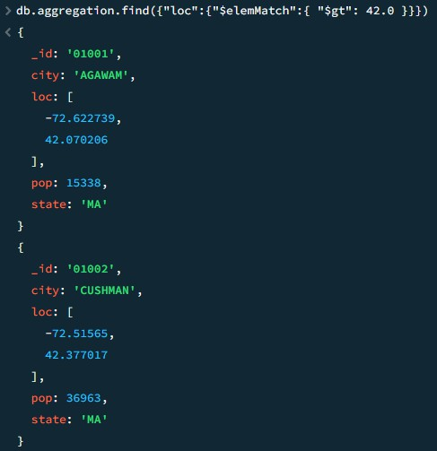

3.size

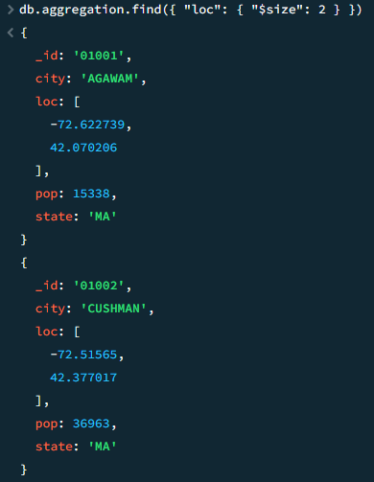

ADVANCED OPERATORS.

1. 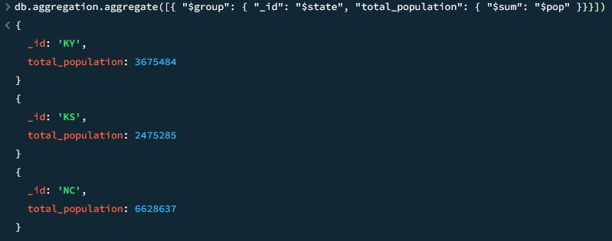group - Find the **total population** of each state.
2. match - Find cities in **state "MA"** with a population greater than **20,000**.

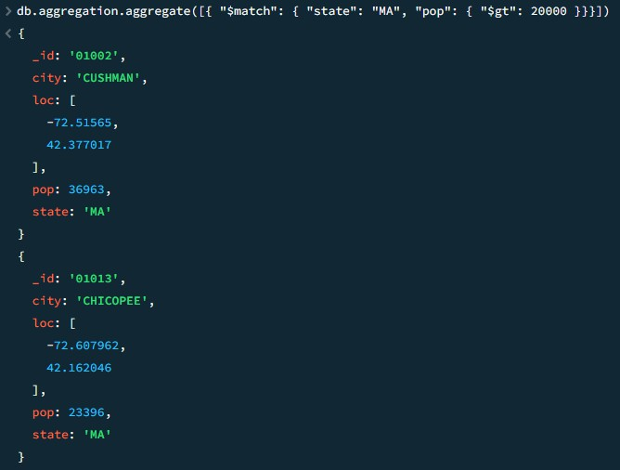

1. 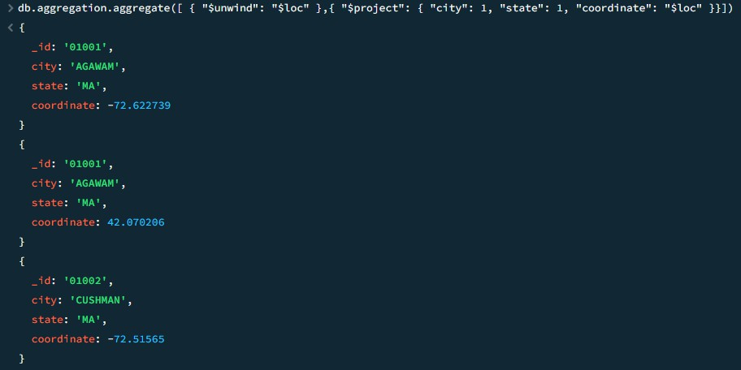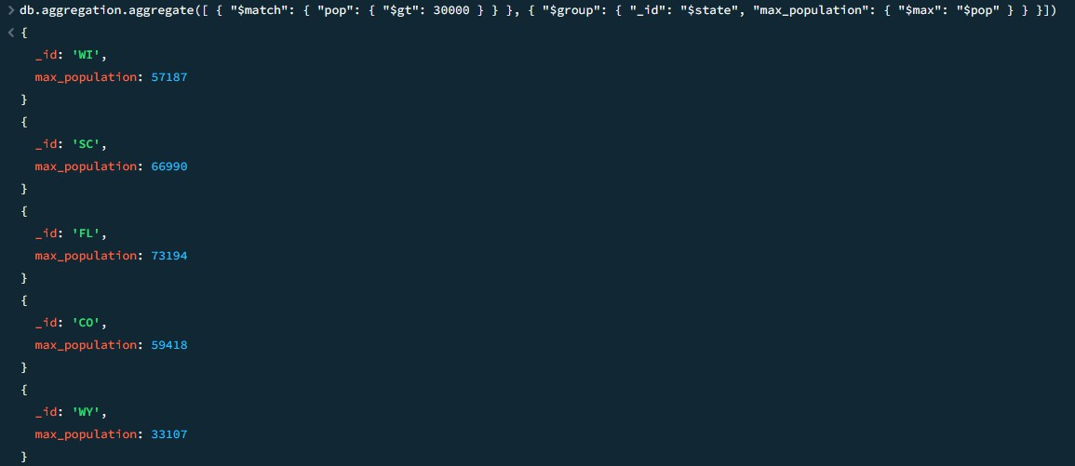unwind
2. sort - Find all cities, sorted by population from lowest to highest

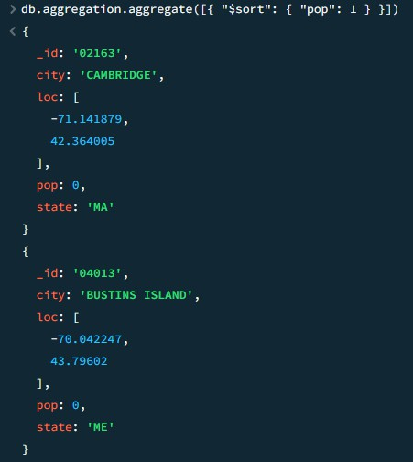

1. Combining all operators.